**EMPLOYEE CHURN PREDICTION:**

import numpy as np

import pandas as pd

**# Load data**

data=pd.read_csv('HR_comma_sep.csv')

data.head()

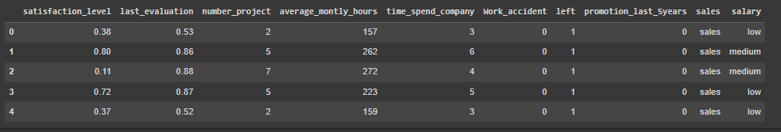

# Import LabelEncoder

from sklearn import preprocessing

# Creating labelEncoder

le = preprocessing.LabelEncoder()

# Converting string labels into numbers.

data['salary']=le.fit_transform(data['salary'])

data['sales ']=le.fit_transform(data['sales '])

# Spliting data into Feature and

X=data[['satisfaction_level', 'last_evaluation', 'number_project', 'average_montly_hours', 'time_spend_company', 'Work_accident', 'promotion_last_5years', 'sales ', 'salary']]

y=data['left']

# Import train_test_split function

from sklearn.model_selection import train_test_split

# Split dataset into training set and test set

X_train, X_test, y_train, y_test = train_test_split(X, y, test_size=0.3, random_state=42)

# Import MLPClassifer

from sklearn.neural_network import MLPClassifier

# Create model object

clf = MLPClassifier(hidden_layer_sizes=(6,5),

random_state=5,

verbose=True,

learning_rate_init=0.01)

# Fit data onto the model

clf.fit(X_train,y_train)

**output:**

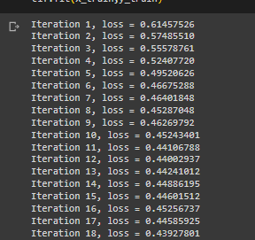

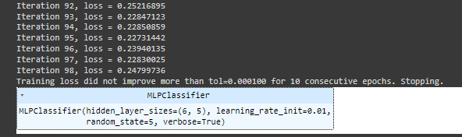

# Make prediction on test dataset

ypred=clf.predict(X_test)

# Import accuracy score

from sklearn.metrics import accuracy_score

# Calcuate accuracy

accuracy_score(y_test,ypred)

output:

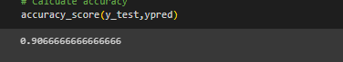

**Week - 5**

**Module Name: Removing noise from the images**

**Exercise: Implement Multi-Layer Perceptron algorithm for Image denoising hyperparameter tuning**

**#tensorflow week -5**

import tensorflow as tf

from tensorflow.keras.datasets import mnist

from tensorflow.keras.models import Sequential

from tensorflow.keras.layers import Dense, Flatten

from tensorflow.keras.utils import to_categorical

**#load the mnist dataset**

(x_train,y_train),(x_test,y_test)=mnist.load_data()

print(x_train)

**#normalize pixel values to eb between 0 and 1**

x_train,x_test=x_train/255.0,x_test/255.0

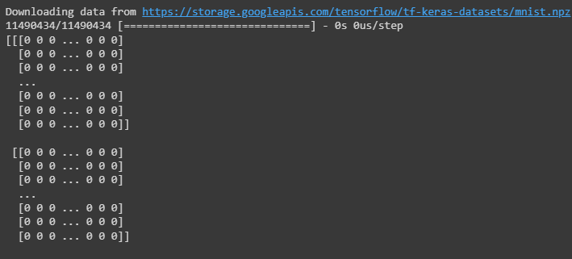

y_train=to_categorical(y_train,num_classes=10)

y_test=to_categorical(y_test,num_classes=10)

model=Sequential([

Flatten(input_shape=(28,28)),

Dense(128,activation='relu'),

Dense(64,activation='relu'),

Dense(10,activation='softmax')

])

**#compilethe model**

model.compile(optimizer='adam',loss='categorical_crossentropy',

metrics=['accuracy'])

**#train th model**

model.fit(x_train,y_train,epochs=5,batch_size=325,validation_split=0.2)

**#evaluate the model on the test data**

test_loss,test_accuracy=model.evaluate(x_test,y_test)

print(f"test Accuracy:{ test_accuracy}")

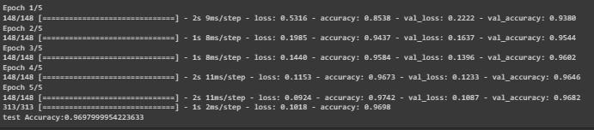

**Week -1:**

**Course name : .Build a Convolution Neural Network for Image Recognition.**

**Program:**

import numpy as np

import tensorflow as tf

from tensorflow.keras import layers,models

from tensorflow.keras.datasets import mnist

(train_images,train_labels),(test_images,test_labels)=mnist.load_data()

**Output:**



train_images,test_images=train_images/255.0,test_images/255.0

train_labels=tf.keras.utils.to_categorical(train_labels,10)

test_labels=tf.keras.utils.to_categorical(test_labels,10)

**# building the cnn**

model=models.Sequential()

model.add(layers.Conv2D(32,(3,3),activation='relu',input_shape=(28,28,1)))

model.add(layers.MaxPooling2D((2,2)))

model.add(layers.Conv2D(64,(3,3),activation='relu'))

model.add(layers.MaxPooling2D((2,2)))

model.add(layers.Flatten())

model.add(layers.Dense(64,activation='relu'))

model.add(layers.Dense(10,activation='softmax'))

**#compile the model**

model.compile(optimizer='adam',loss='categorical_crossentropy',metrics=['accuracy'])

**#train the model on training data**

model.fit(train_images.reshape(-1,28,28,1),train_labels,epochs=5,batch_size=64)

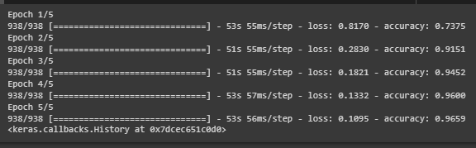

**#evaluate the model on test data**

test_loss,test_accuracy=model.evaluate(test_images.reshape(-1,28,28,1),test_labels)

print("test accuracy :",test_accuracy)



**Week-2:**

**Module name : Understanding and Using ANN : Identifying age group of an actor**

**Exercise : Design Artificial Neural Networks for Identifying and Classifying an actor using Kaggle Dataset.**

**Program:**

from tensorflow.keras.models import load_model

from PIL import Image

import numpy as np

image_height=128

image_width=128

num_channels=3

model=load_model('trained_model_NEW_2_2_Dataset.h5')

new_face_path='/content/jk.jpg'

new_face=image.open(new_face_path)

**output:**